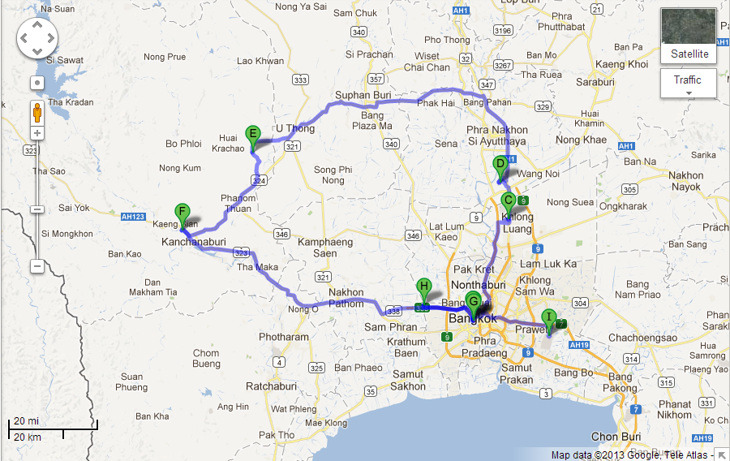

Point | Location | From point before | From BangKok
A | Bangkok
B | The Temple of Emerald Buddha | 5 min | 5 mins
C | AIT Thailand | 1 hr | 1 hr
D | Bangpa-in Industrial Estate | 0.5 hr | 1 hr
E | TSE 01 Project | 2 hr | 2 hr
F | River Kwai Bridge | 1 hr | 3.5 hr
G | Blue Line MRT | 2 hr | 4 min
H | Mahidol University | 0.5 hr | 0.5 hr
I | Suvarnabhumi Airport | 1 hr | 0.5 hr

